Subject: January is National Human Trafficking Prevention Month

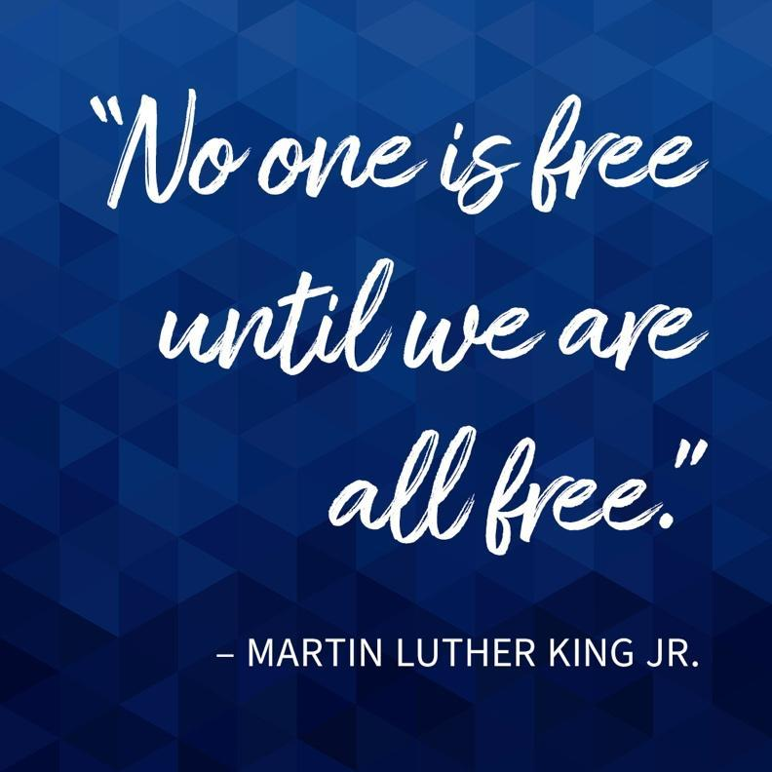
[Customize with your Image or use ours]
Dear Partners,

In 2010 President Barak Obama designated January as National Human Trafficking Prevention Month, culminating in the annual celebration of National Freedom Day on February 1. Since that time, January has become a month to remind ourselves of the vital role we each can play in ending Human Trafficking.

[choose a few of the data points below or share data, or an impact story from your own community]

Recent statistics tell us that:

- The International Labor Organization 2022 report estimates there are an estimated 27.6 million victims of forced labor globally where 3.3 million of the victims are children.
- Human Trafficking is an estimated $150 billion industry that takes place in all industries, to individuals of all genders, age, and socio-economic status.
- Polaris Project has identified 25 industries in which both labor and sex trafficking thrive in the United States.
- In 2020 the National Human Trafficking Hotline identified 10,583 trafficking situations in the United States. California reported 1,334 cases in 2020, and 268 of these cases involved minors
- 1 in 6 of the more than 25,000 children reported missing in 2021 to NCMEC were likely victims of child sex trafficking.
- In 2020, there was a record 21.7 million reports of suspected child sexual
exploitation made to NCMEC’s CyberTipline.
- Nearly one in five of 911 youth interviewed in the Covenant House National
Study of homeless youth were victims of trafficking, 15% for sex, 7.4% for labor and 3% for both.
- Since June 1, 2016 through December of 2021, the Child Trafficking Response Team reports that Statewide, there have been 6,888 CSEC children victimized or ‘at risk’ in child welfare and probation
- In [INSERT COUNTY NAME] County there have been [INSET NUMBER OF YOUTH IDENTIFIED] as exploited or trafficked youth during [INSERT TIME FRAME] or another local data point.

This January, [INSERT ORGANIZATION NAME] celebrates those who have worked fearlessly to end injustice in our own communities. We continue to commit to partnership, as we work to create a future where our children, youth and families may thrive free from exploitation. We urge you to join by taking one step today to inspire change!

[Insert link to your website or ours here. “Check out Preventing and Addressing Child Trafficking Project’s National Human Trafficking Prevention Month Website to learn ways you can get involved!”]

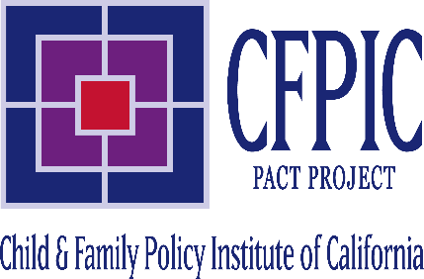
In Collaboration, [INSERT]

