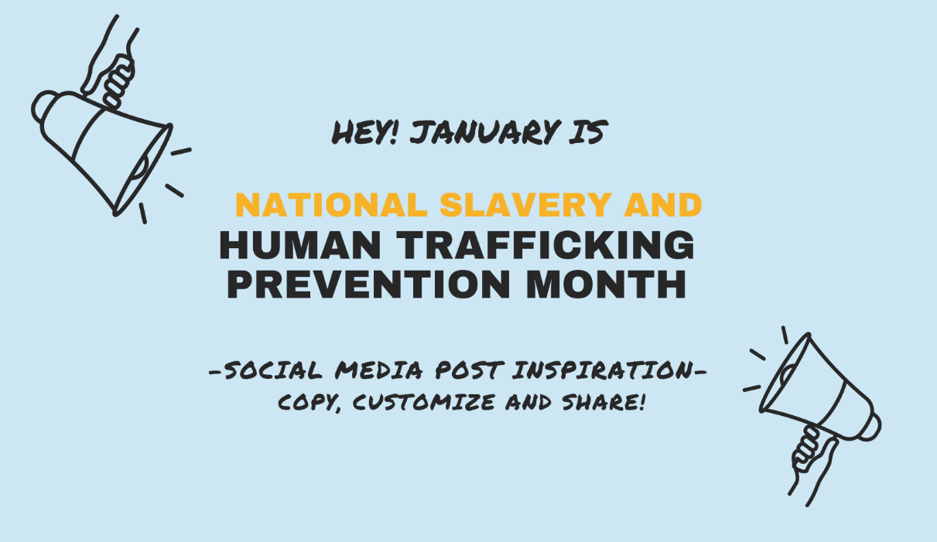

We’ve done the work for you!

Use the social media content we’ve developed in any order based on what’s most relevant to your community. Don’t stop there! Create or customize your own. Before you get started, reflect on our social media checklist to assist your team in developing both ethical and meaningful content.

- Ask yourself: what is my intention with sharing this post?
- Link to reputable sources
- Cite your data or link to the source
- Give credit to the original creator or photographer if sharing an image
- Think twice before posting a personal photo that may identify an individual
- If groups or individuals are in images, receive informed consent and always consider safety
- Avoid sweeping generalizations
- Challenge perceptions and bring down stereotypes
- Promote diversity
- Be respectful of cultures and traditions
- Don’t portray yourself or your organization as the “hero” if a post highlights client services, or stories
- Share with hope and inspire actionable change!

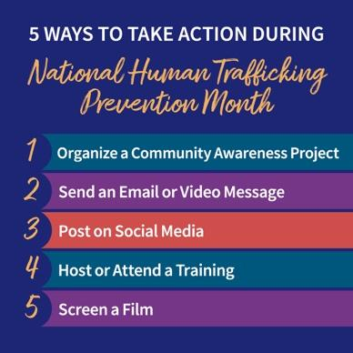
Post 1.

Link: http://pact.cfpic.org/htpm2023

“Happy New Year!

In 2010 President Barak Obama first designated January as National Human Trafficking Prevention Month. In January we newly commit to building a future where our children, youth and families may thrive free from exploitation.

Check out CFPIC’s Preventing and Addressing Child Trafficking Project’s Action Steps to inspire change!

Post 2.
Link: https://archive.storycorps.org/client/office-on-trafficking-in-persons/

National Human Trafficking Prevention Month is a time to raise awareness and take collective action to prevent and end exploitation for all. Today we honor first and foremost the survivors and thrivers, whose resilient voices shape and inspire our local and national work.

Visit StoryCorps Human Trafficking Archive to hear from survivor leaders, activists and those have informed, shaped, and contributed to the successes of the anti-trafficking field over the past two decades.

Post 3.
Link: https://polarisproject.org/national-human-trafficking-hotline/

The National Human Trafficking Hotline is a national, toll-free hotline, available to answer calls, texts, emails, and live chats from anywhere in the United States, 24 hours a day, 7 days a week, in more than 200 languages. Call 1-888-373-7888, Text 233733 (Befree), or Live Chat for round-the-clock access to a safe space to report tips, seek services, and ask for help.

Post 4.
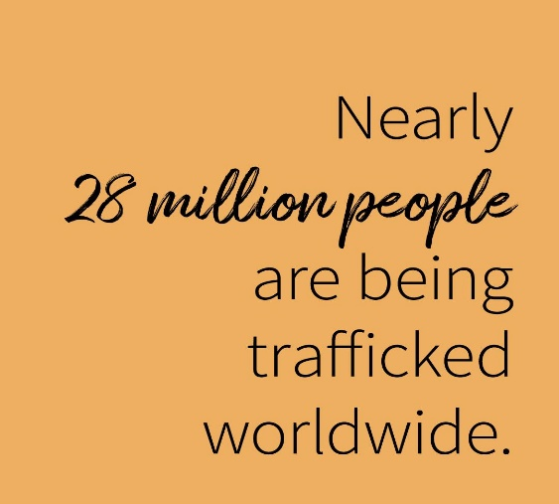
Link: https://www.ilo.org/wcmsp5/groups/public/@ed_norm/@ipec/documents/publication/wcms_854795.pdf
According to the International Labor Organization there are 27.6 million people in situations of forced labour on any given day, with 6.3 million in situations of forced commercial sexual exploitation.

Post 5.
Link: https://polarisproject.org/the-typology-of-modern-slavery/

Polaris documented more than 32,000 cases of human trafficking between 2007 and 2016 through its operation of the National Human Trafficking Hotline — “The Typology Report” report identifies 25 industries in the United States where labor and sex trafficking thrive.

Post 6.
Link/Image: https://redsandproject.org/sidewalk-installations/
The Red Sand Project is a free and easy way to gather a group in your community to raise awareness by creating a sidewalk installation. Make sure to share your event on social media #RedSandProject to connect to thousands of others worldwide. Order your sand for free HERE.

Post 7.
Link: https://www.covenanthouse.org/homeless-issues/human-trafficking

Runaway and homeless youth are especially vulnerable to trafficking. The National Covenant House National Study revealed that sixty-eight percent of the youth who had either been trafficked or engaged in survival sex, had done so while homeless. Nearly one in five of the 911 youth interviewed were victims of trafficking. 15% were sex trafficking victims, 7.4% for labor, and 3% for both.

Post 8.
Link: https://abolitionistmom.org/
Image: https://abolitionistmom.org/posters/

Educate your community to prevent exploitation before it starts. Learn more about the Disrupt Sex Trafficking campaign by Abolitionist Mom to order community posters or download images to share on social media today.

Post 9. Share a partner’s upcoming event. See our calendar for more ideas! Here’s a sample:

Link: http://pact.cfpic.org/htpm2023

Educate yourself during National Slavery and Human Trafficking Prevention Month! Check out PACT’s Statewide Event Calendar to discover opportunities like ___ (INSERT LOCAL EVENT) ___

Post 10.
Link: https://pact.cfpic.org/wp-content/uploads/2021/12/PPT-Slides-CCWIP-CWDA-Analysis-Oct-2020-1.pdf

Talk to a young person in your life today to share the warning signs of human trafficking!

Since California’s passage of SB 855 in 2014, 14,892 youth have been identified by Child Welfare Services for suspected exploitation and/or trafficking. Of these youth, 9,297 were the subject of one or more allegations of exploitation before the age of 18 years of age. Source CA Child Welfare Indicators Project, UC Berkeley

Post 11 - National Human Trafficking Awareness Day (January 11th)
Link: https://www.dhs.gov/blue-campaign/wearblueday
Images: https://www.dhs.gov/sites/default/files/images/wbd_webpage_graphics_instagram1.jpg
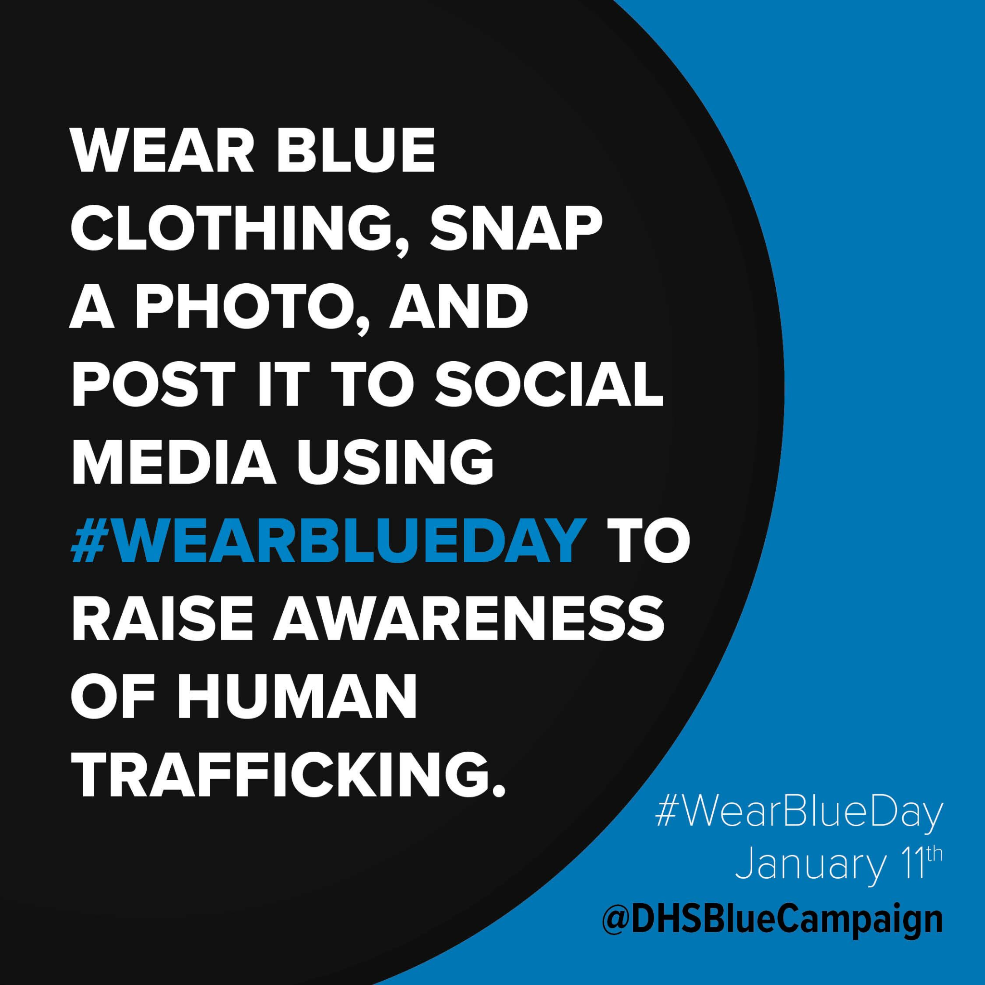
Today is National Human Trafficking Awareness Day! Show your support by wearing blue on Human Trafficking Awareness Day. Follow @DHSBlueCampaign on Facebook, Twitter, and Instagram for more information about #WearBlueDay and Campaign efforts throughout the year.

Post 12.
Link: https://www.missingkids.org/theissues/trafficking
In 2020, there was a record 21.7 million reports of suspected child sexual exploitation made to the National Center for Exploited Children’s CyberTipline. Child sex trafficking can have devastating immediate and long-term consequences, including health impacts, psychological and physical trauma, and even death. Prevention and intervention are key to keeping children safer. Report ALL missing children, especially children who have run away, to NCMEC by calling 1-800-THE-LOST (1-800-843-5678).

Post 13.
Link: https://polarisproject.org/myths-facts-and-statistics/

Myth or Fact? The most pervasive myth about human trafficking is that it often involves kidnapping or physically forcing someone into a situation. In reality, most traffickers use psychological means such as tricking, defrauding, manipulating, or threatening victims into providing commercial sex or exploitative labor. Learn more Human Trafficking Myth Busters @ PolarisProject.Org

Post 14.
Link: https://humantraffickinghotline.org/states
The most recent data analysis from the National Human Trafficking Hotline identified 10,583 cases of human trafficking. California had the highest number of reported cases 1,334 cases, 26% more than the next state (Texas). 1 in 5 of all incidents involved children and youth under the age of 18.
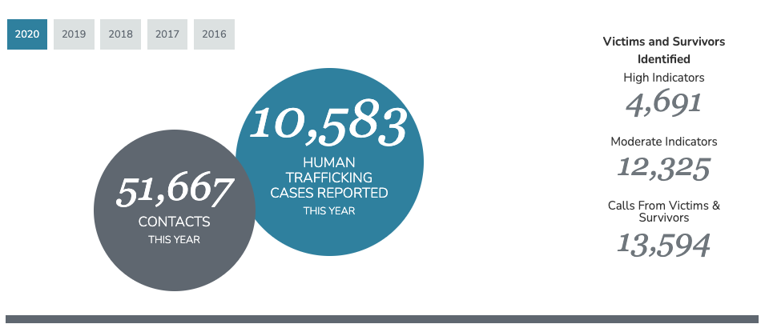

Post 15.
Link: https://storycorps.org/participate/

Have a story to share?! Last year, StoryCorp linked up with the Office on Trafficking in Persons to collect “Voices of Freedom”. The project captures oral histories - recorded conversations with those who have informed, shaped, and contributed to the successes of the anti-trafficking field over the past two decades. Check out a featured interview. There is still time to add your own!

Post 16.
Link: Add your own

It’s all about partnership! Today we are grateful for (add local organization/link___). Their work is critical to our community in the fight to end human trafficking! Learn more about (add local organization/link website or social media).
[Tips:
If you’re not sure who to highlight, consider:
- You can highlight a community partner that serves children and families (even if they aren’t an anti-trafficking organization)
- Select an organization you feel comfortable and confident highlighting because their work has integrity and is trauma-informed.
- If you don’t have a local organization to share, select a statewide or national organization, such as NCMEC, POLARIS, Framework TA, OVC TTAC, NHTTAC.]

Post 17.
Link: www.missingkids.org/theissues/trafficking

Did you know? “Buyer perpetuated trafficking” is when a child is being exploited but does not have an identified trafficker. Instead, the buyer targets a youth’s vulnerabilities by offering money, food, and/or shelter in exchange for sex. Learn about other types of trafficking at www.missingkids.org/theissues/trafficking

Post 18.
Link: https://humantraffickinghotline.org/human-trafficking/recognizing-signs

Most survivors don’t self-identify or disclose their abuse because of fear, shame or loyalty to their abuser(s). Professionals, trusted adults, and even peers might be the first to recognize the signs. Click Here to Learn more about the red flags of sex and labor trafficking.

Post 19.
Link:
https://cfpic.org/wp-content/uploads/2021/02/Child-Labor-Trafficking-Mini-Desk-Guide-1.pdf

Child labor trafficking has received comparatively little attention to sex trafficking. Yet, a 2016-2018 analysis of CA child trafficking cases reported to the National Human Trafficking Hotline, identified that 13% to 17% of cases involved profiting off a child for their labor or services. The top industries included peddling and begging, domestic work and traveling sales crews.

Check out PACT’s Child Labor Trafficking Mini-Desk Guide to learn more!

Post 20.
Link: https://polarisproject.org/resources/breaking-barriers-improving-services-for-lgbtq-human-trafficking-victims/

Although anyone can be trafficked, LGBTQIA+ Youth are particularly vulnerable due to the absence of strong support networks, marginalization, and high rates of prior histories of violence. To learn more about creating safe spaces in your programs for LGBTQIA+ Youth, read
the Polaris Project’s report “Breaking Barriers: Improving Services for LGBTQ+ Human Trafficking Victims”
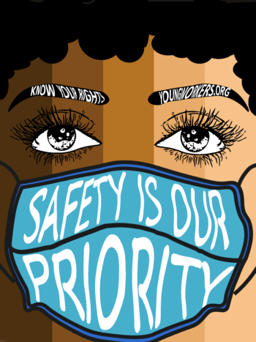
Post 21.

Link: https://youngworkers.org/
Image: Safety is our priority (right)
Youth are often targeted by traffickers with fraudulent job opportunities that are too good to be true! Prevent labor trafficking by educating youth about their rights in the workplace. Check out resources today @ youngworkers.org

Post 22.
Link: https://vimeo.com/ondemand/boysdoc
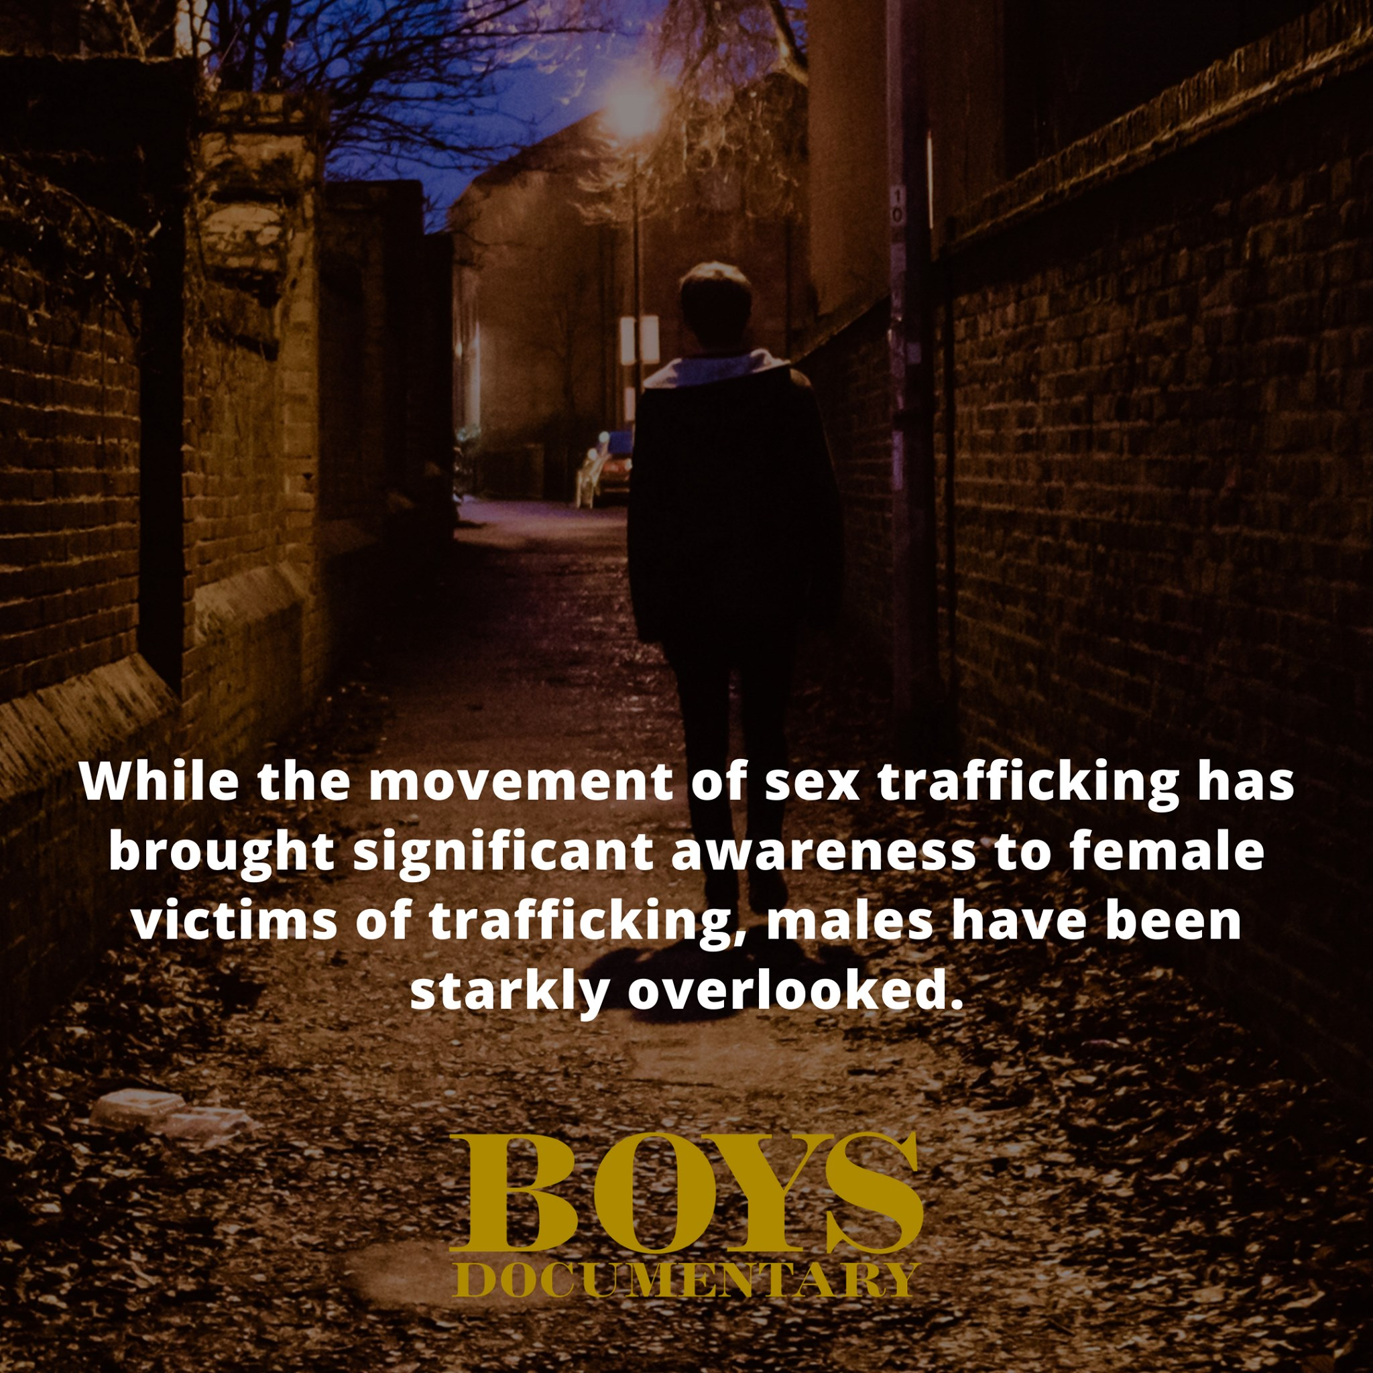

Boys and men are just as likely to be victims of human trafficking as girls and women, however, they are less likely to be identified and reported. A recent national study found that 36% of youth involved in the sex trade identified as cisgender males.

Stream the documentary BOYS (or host a community screening) featuring the voices of four brave men and a collection of allies who stand in solidarity as they share their experiences.

Post 23.
Link to Video:
https://www.facebook.com/SovereignBodiesInstitute/videos/1739783132858219

Link: https://strongheartshelpline.org

Native American and indigenous youth are at higher risk for exploitation due to prior history of violence and intergenerational trauma. Refer survivors to StrongHearts Native Helpline - a culturally appropriate domestic, dating, and sexual violence helpline for Native Americans, offering support and referrals to resources available 24/7. Call/text 1-844-762-8483 or Live Chat

Post 24.
Link: https://www.ovcttac.gov/taskforceguide/eguide/4-supporting-victims/41-using-a-trauma-informed-approach/

“Before you address trauma, you have to address basic needs. If housing isn’t stabilized, if someone hasn’t eaten, or slept well for a long time, or has medical issues, they can’t focus on doing any deeper healing.” – Anonymous Survivor

Learn more about a trauma-informed approach to support survivors of human trafficking @ Office of Victims of Crime Training and Technical Assistance Center.

Post 25.
Link: https://www.youtube.com/watch?v=nw_ZZ-5DSEs&t=522s

When youth are forced to commit crimes on behalf of their trafficker they experience a form of child labor trafficking. These young people may have more in common with children in armed conflict zones than we realize. Learn more by watching a short clip from “Jimmy” who shares his experience of gang related trafficking and forced drug transport. *Triggering content advisory.

Post 26.
Link: https://www.acf.hhs.gov/otip/training-technical-assistance/resource/monthlywebinars

Did you know that the amended Trafficking Victims Protection Act requires government officials to report suspicion of the trafficking of a foreign born minor to the Office on Trafficking in Persons (OTIP). Learn more by attending a Monthly Child Eligibility Webinar which provides an overview of reporting requirements and the local and federal benefits (including immigration assistance, housing support and more).

Post 27.
Link: https://www.cdss.ca.gov/Portals/9/ACIN/2018/I-59_18_1.pdf?ver=2018-10-12-151654-683

Harm Reduction is considered a best practice in supporting youth who have experienced exploitation. CDSS’s Child Trafficking Response shares in the Introduction to the Harm Reduction Series:
“It is essential that practitioners create opportunities for choice and more importantly, opportunities to meet the totality of a youth’s needs, not just those that are met through the exploitive situation.” Learn more by reading the Introduction to the Harm Reduction Series Guidance.

Post 28.
Link: https://www.ethicalstorytelling.com/resources/

Heard any good stories lately? Stories shape our culture and build community - and how we tell them matters. Does your team or partners need guidance? Check out resources (most are free!) at www.ethicalstorytelling.com/ - You’ll find podcasts, presentations, and more from this group of nonprofit practitioners.

Post 29.
Link: https://pact.cfpic.org/wp-content/uploads/2022/05/PACT-Prevention-Curriculum-Resource-Guide-2021.pdf

Do you agree that prevention is the way towards a brighter future? This month and beyond, keep on educating young people, families and our communities about human trafficking! Check out PACT’s Prevention Guide, a compilation of California specific resources including available trainers and existing prevention programs.

For more resources and to access January’s Event Calendar visit the PACT National Human Trafficking Prevention Month Resource Website.

